Problem 4

Find the current *i* and the voltage *v* across LED diode in the circuit shown on Fig. a) assuming that the diode characteristic is shown on Fig. b).

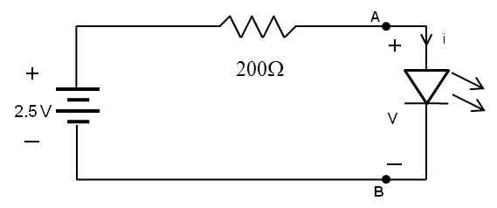

Fig. a)

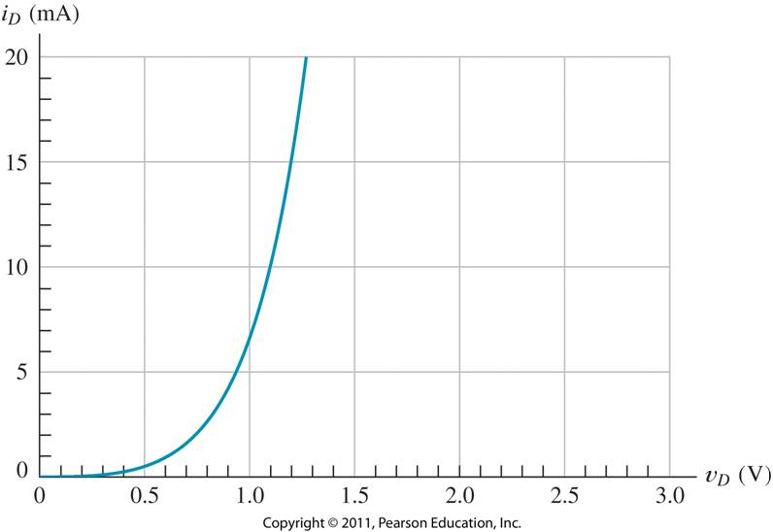

Fig. b)